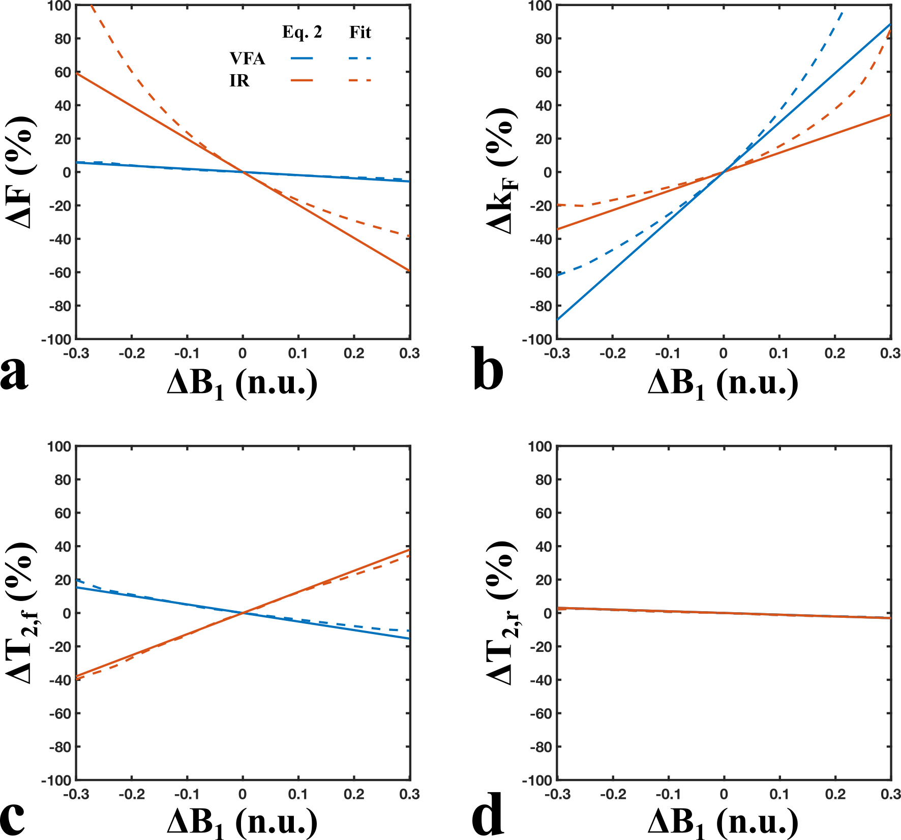

<b>Figure 1.</b> Simulated qMT parameter errors due to B<sub>1</sub>-inaccuracies (-30% < ΔB<sub>1</sub> < 30%) considering a B<sub>1</sub>-independent T<sub>1</sub> measurement (red: IR – inversion recovery) and a B<sub>1</sub>-dependent T<sub>1</sub>-measurement (blue: VFA – variable flip angle). Solid lines are parameter errors calculated from minimizing Eq. 2 (first-order approximation of the Taylor expansion), and dashed lines are parameter errors calculated from fitting the qMT signal according to the Sled & Pike model. The tissue parameters (white matter) and qMT protocol (uniform) were matched to those presented in Boudreau et al. 2017 (see Fig. 3 of the paper).

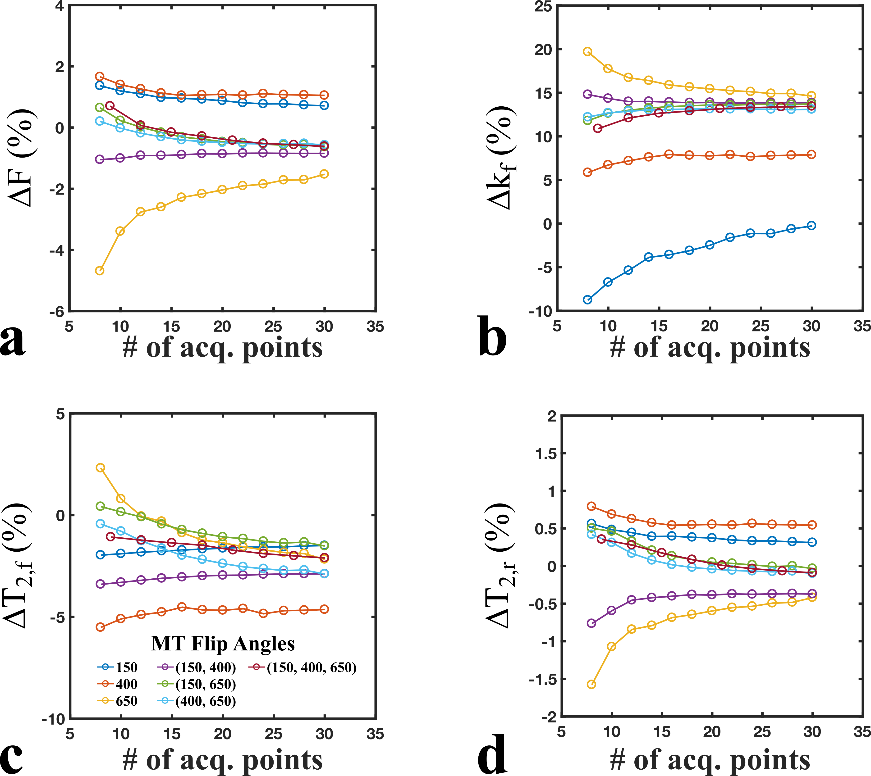

<b>Figure 2.</b> Simulated qMT parameter errors estimated from Eq. 2 for ΔB<sub>1</sub>=0.05 for a wide range of logarithmically-uniform (offsets) qMT protocols. Single (blue, orange, yellow), dual (purple, green, light blue), and triple (red) flip angle combinations of 150°, 400°, and 600° were compared. The number of offset frequencies were uniformly distributed between 300 Hz and 20 kHz, and matched for the total number of acquisition points (# offsets × # flip angles).

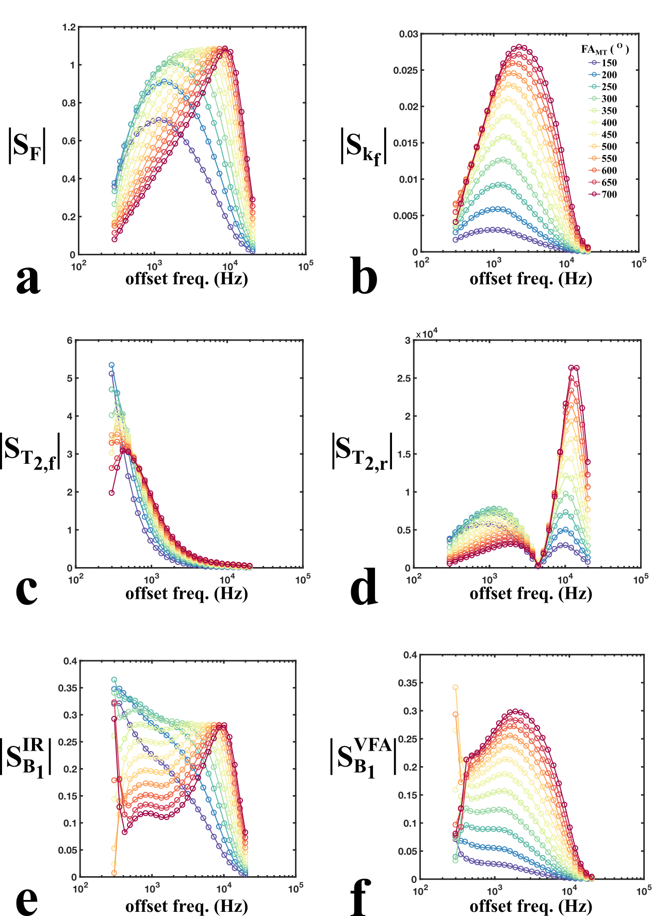

<b>Figure 3.</b> Sensitivity values (magnitudes) for each qMT fitting parameters (F, k<sub>f</sub>, T<sub>2,f</sub>, T<sub>2,r</sub>) and B<sub>1</sub> measurement values considering a B<sub>1</sub>-independent T<sub>1</sub> measure (IR – inversion recovery) and a B<sub>1</sub>-dependent T<sub>1</sub> measure (VFA – variable flip angle). The 312-point protocol shown (12 flip angles x 26 offset frequencies) represents the initial search-space used for protocol optimization. The sets of sensitivity values for each fitting parameter (<b>a–d</b>) consists of the matrix columns of the Jacobian sensitivity matrix (<b>S<sub><i>p</i></sub></b> in Eq. 2 and 5).

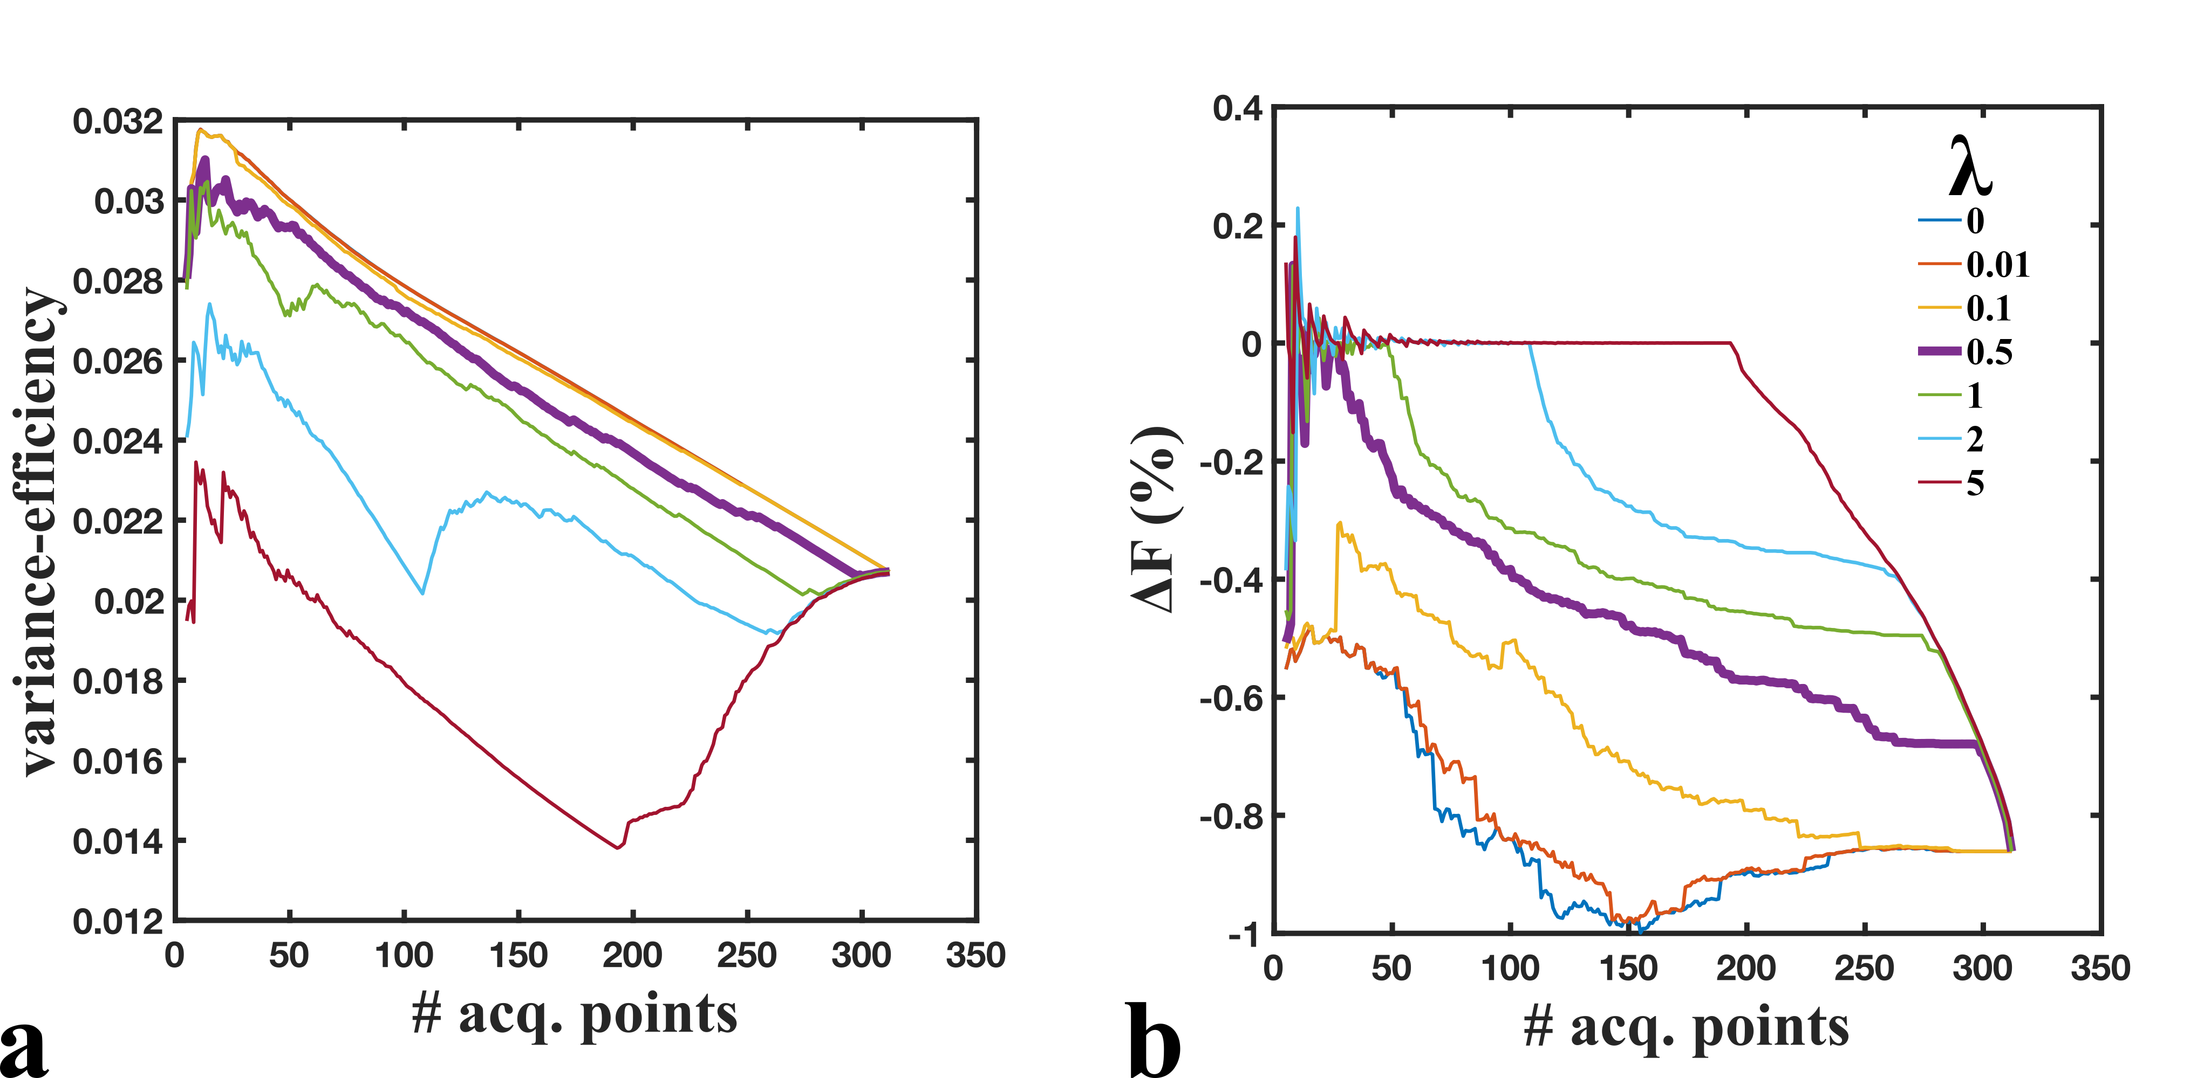

<b>Figure 4.</b> Variance-efficiency (a) and ΔF (b) (Eq. 2, ΔB<sub>1</sub> = 5%) values during the iterative optimization of the sensitivity-regularized Cramer-Rao Lower-Bound equation (Eq. 5). Variance-efficiency is defined here as (variance × # acq. points)<sup>-1/2</sup>, where the variance is interpreted to be the parameter-normalized Cramer-Rao Lower Bound (<i>V</i>, Eq. 3).

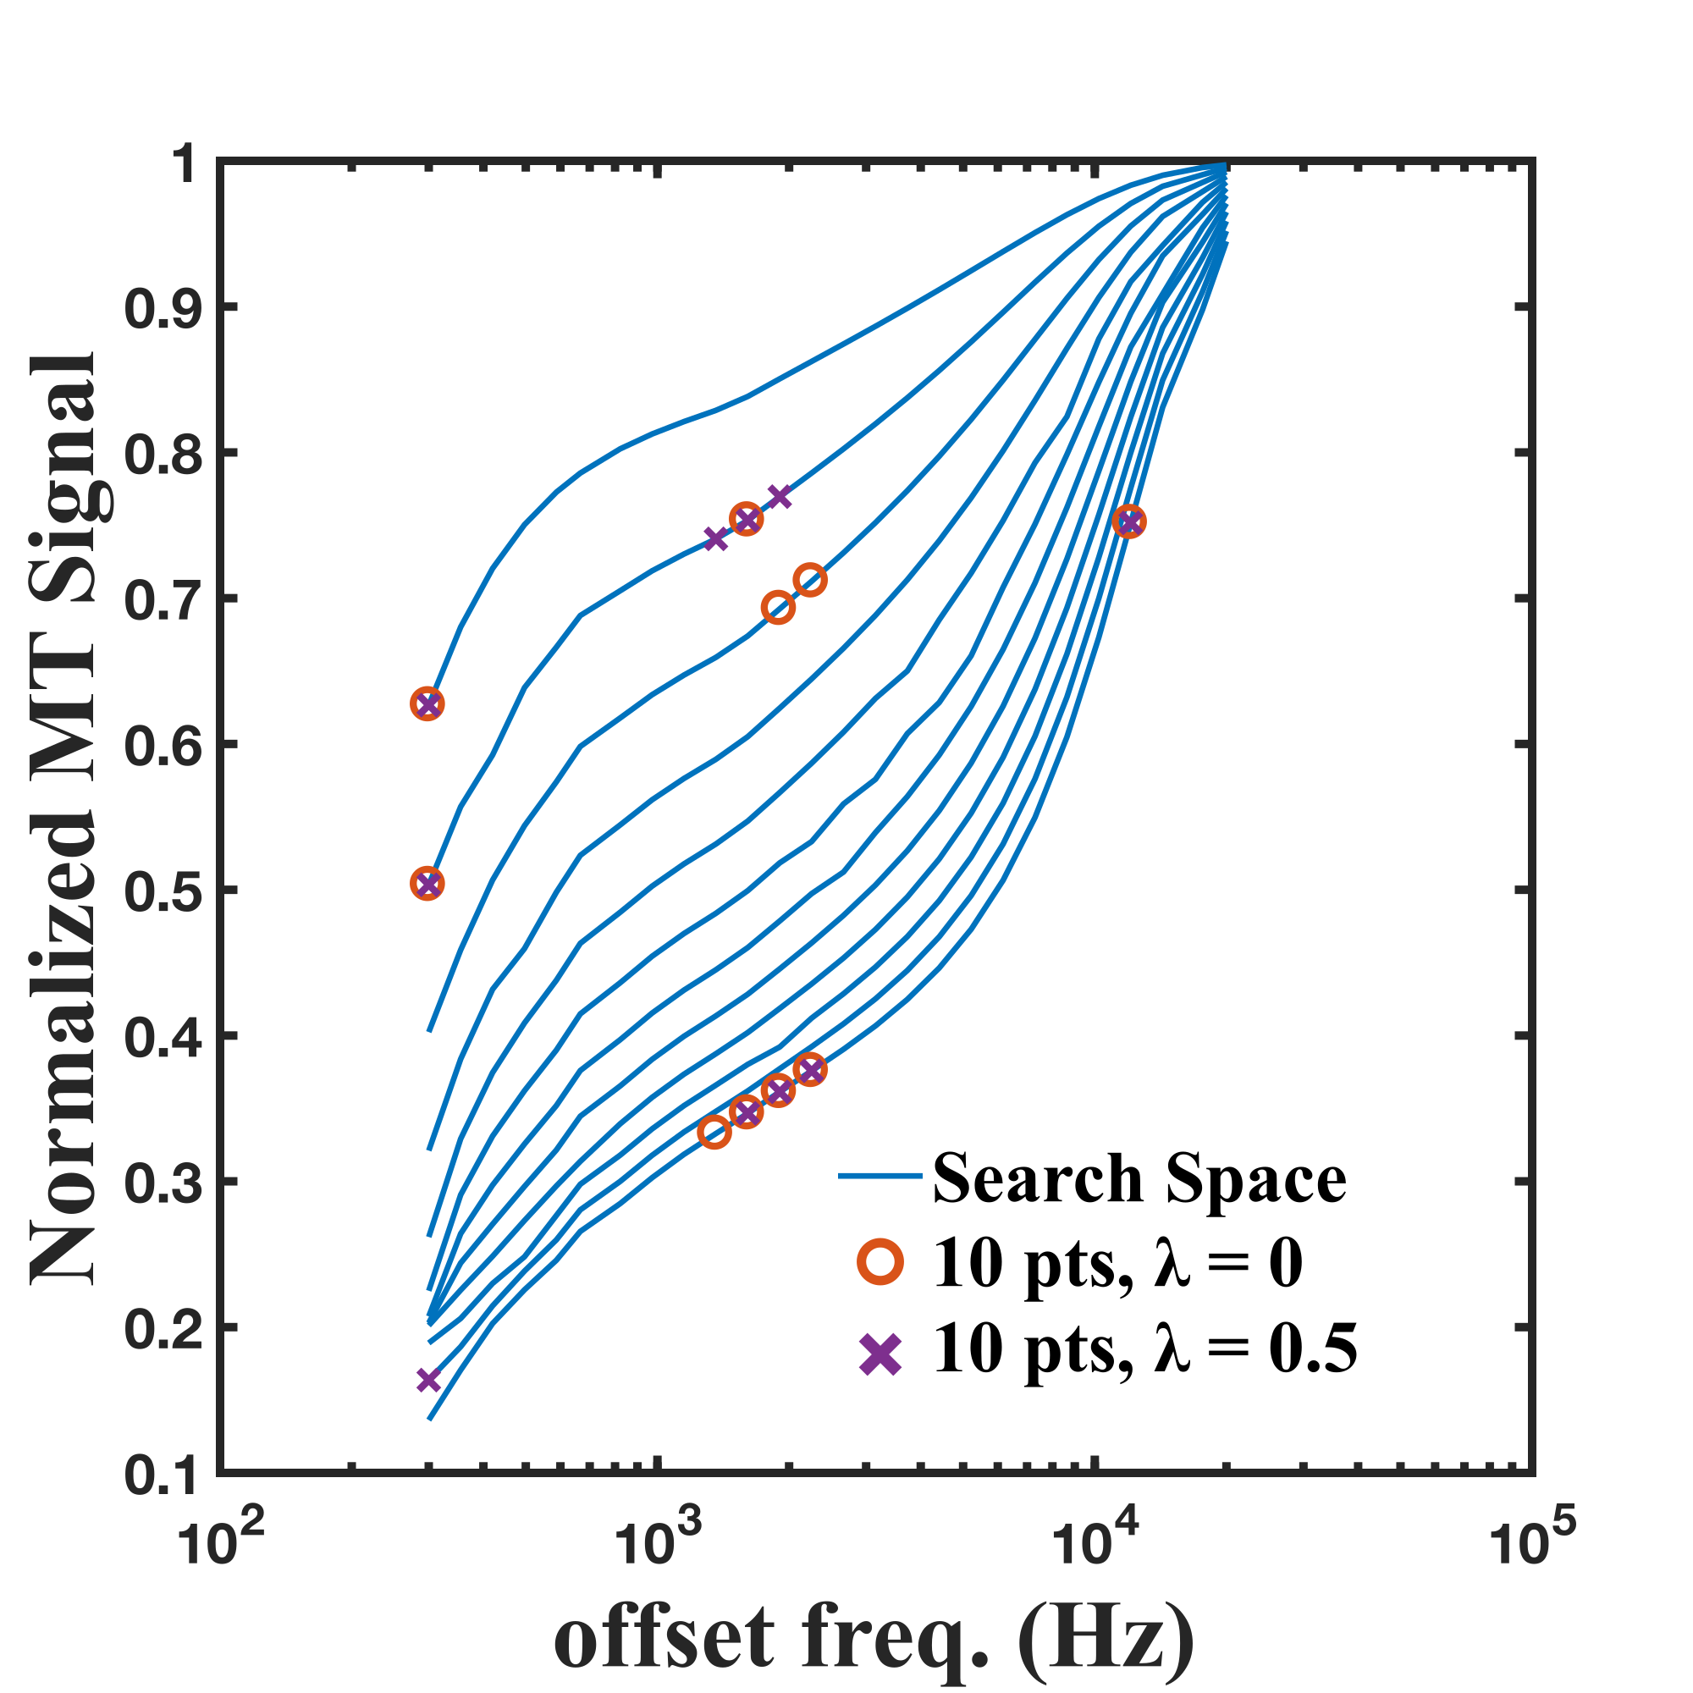

<b>Figure 5.</b> Comparison between the 10-point protocols iteratively optimized from a 312-point search space using solely the parameter-normalized CRLB (λ = 0) and regularized CRLB<sub>λ=0.5</sub>. The different flip angle Z-spectrums of the initial optimization search-space are displayed in blue to emphasize the 10-point protocols. The flip angle Z-spectrums (150° to 700°, in 50° increments) range from the highest MT-signal values curve (150°) to lowest (700°).

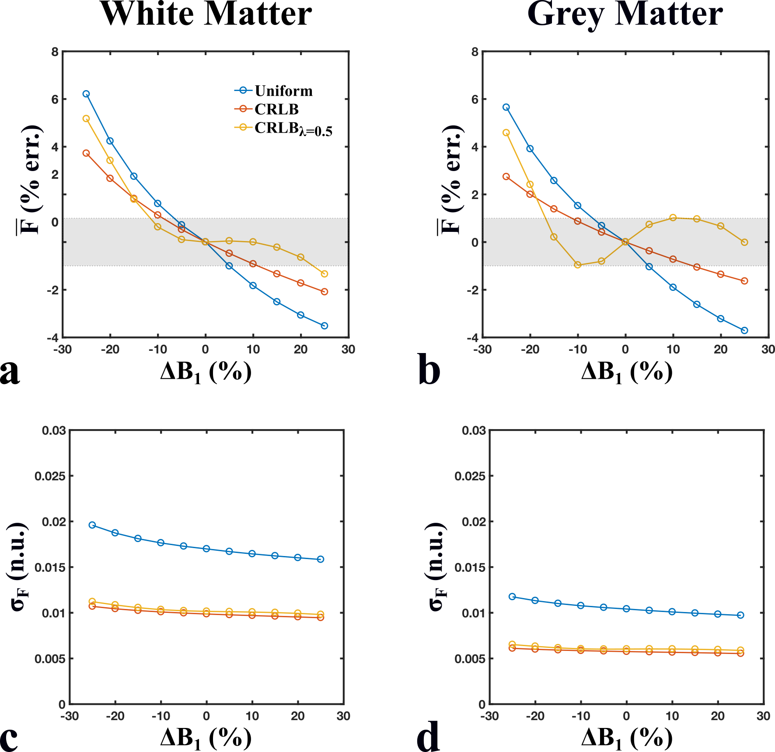

<b>Figure 6.</b> Means (<b>a, b</b>) and standard deviations (<b>c, d</b>) of the distribution of pool-size ratios (F) for sets of Monte Carlo simulations (10,000 runs, SNR = 100) fitted using a range of B<sub>1</sub> errors (ΔB<sub>1</sub> = ±30%, B<sub>1</sub> = 1 n.u.) and for two sets of qMT parameters (white matter – <b>a, c</b>; grey matter – <b>b, d</b>). Mean F values (% error) shown here were compared relative to the accurate B<sub>1</sub> value case (ΔB<sub>1</sub> = 0), and the grey region represents the region of ±1% relative error. Simulated signal values were generated and fitted for three different 10-point qMT protocols: Uniform (blue) – two-FA protocol with logarithmically-uniform off-resonance frequency values, CRLB (red) – protocol optimized by iteratively minimizing the increase in the parameter-normalized Cramer-Rao Lower-Bound of the system, and CRLB<sub>λ=0.5</sub> (yellow) – protocol optimized similar to CRLB, regularized by the estimated error of F (ΔF) in the presence of a B<sub>1</sub> error (Eq. 5).

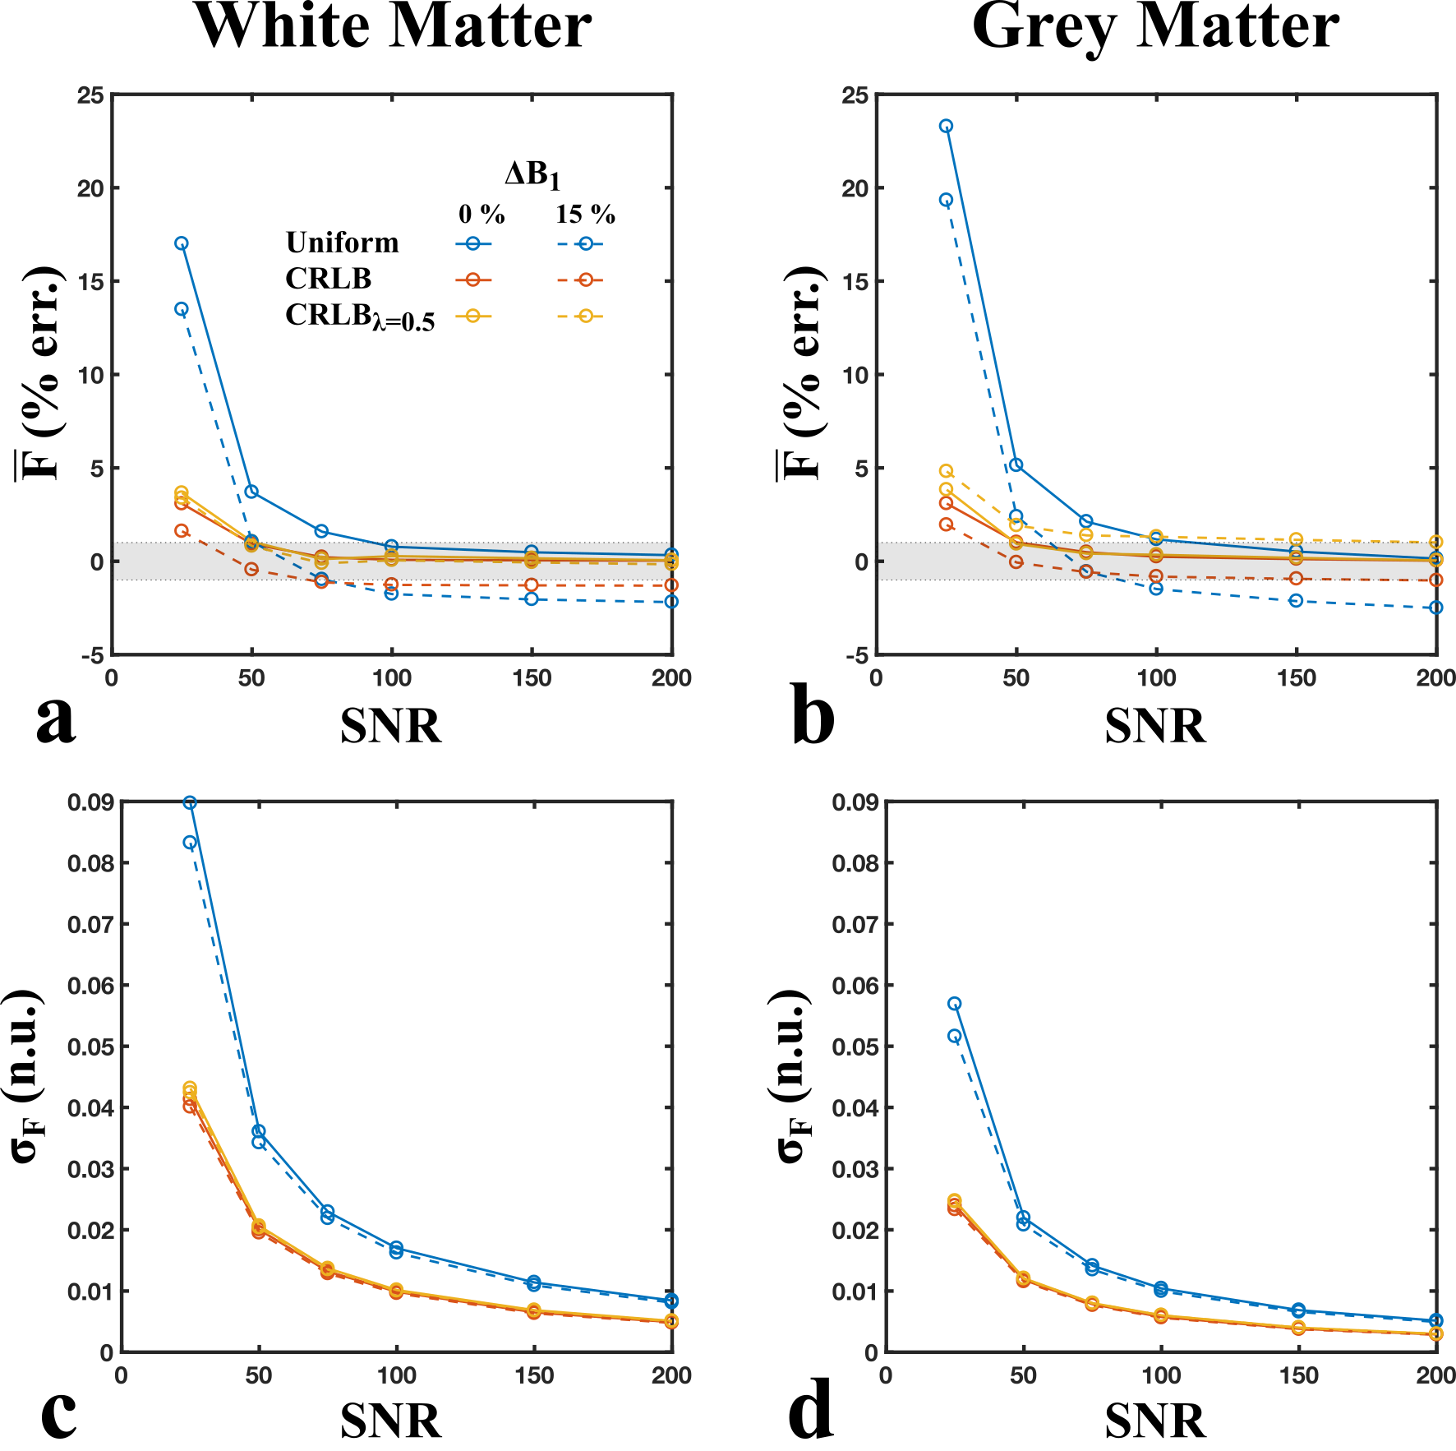

<b>Figure 7.</b> Means (<b>a, b</b>) and standard deviations (<b>c, d</b>) of the distribution of pool-size ratio values (F) for sets of Monte Carlo simulations (10,000 runs) fitted using a range of SNR values (25, 50, 75, 100, 150, and 200) and for two sets of qMT parameters (white matter – <b>a, c</b>; grey matter – <b>b, d</b>). Mean F values (% error) shown here were compared relative to data fitted for an ideal SNR case (noiseless), and the grey region represents the region of ±1% relative error. Data was fitted assuming ideal B<sub>1</sub> values (B<sub>1</sub> = 1 n.u., solid lines) and a 15% overestimation in B<sub>1</sub> (B<sub>1</sub> = 1.15 n.u., dotted lines). Simulated signal values were generated and fitted for three different 10-point qMT protocols: Uniform (blue) – two-FA protocol with logarithmically-uniform off-resonance frequency values, CRLB (red) – protocol optimized by iteratively minimizing the increase in the parameter-normalized Cramer-Rao Lower-Bound of the system, CRLB<sub>λ=0.5</sub> (yellow) – protocol optimized similar to CRLB, regularized by the estimated error of F (ΔF) in the presence of a B<sub>1</sub> error (Eq. 5).